Lab Manual 04: Star Topology Using Switch
Star Topology Using Switch

Introduction
A star topology is a network configuration in which all devices (computers, printers, etc.) are connected to a central device called a switch. The switch manages communication between devices, making the network efficient, reliable, and easy to troubleshoot.

Objective
To design and configure a star topology using a switch and assign IP addresses to ensure communication between devices.

Procedure
- Step 1: Open Simulation Software
Open Cisco Packet Tracer and prepare a blank workspace for network design.
- Step 2: Add Devices (Star Layout)
Place one switch at the centre and add multiple PCs around it to form a star topology.
- Step 3: Connect Devices to Switch
Connect each PC to the switch using straight-through cables (all links should turn green).

● Step 4: Configure IP Addresses
Assign unique IP addresses to each PC within the same network (e.g., 192.168.1.x with subnet mask 255.255.255.0).

● Step 5: Verify Connectivity Using Ping and Packet Simulation
Use the ping command between PCs and test using simulation mode to observe packet flow through the switch.

Screenshots

● Step 1 & 2: Adding Switch and PCs
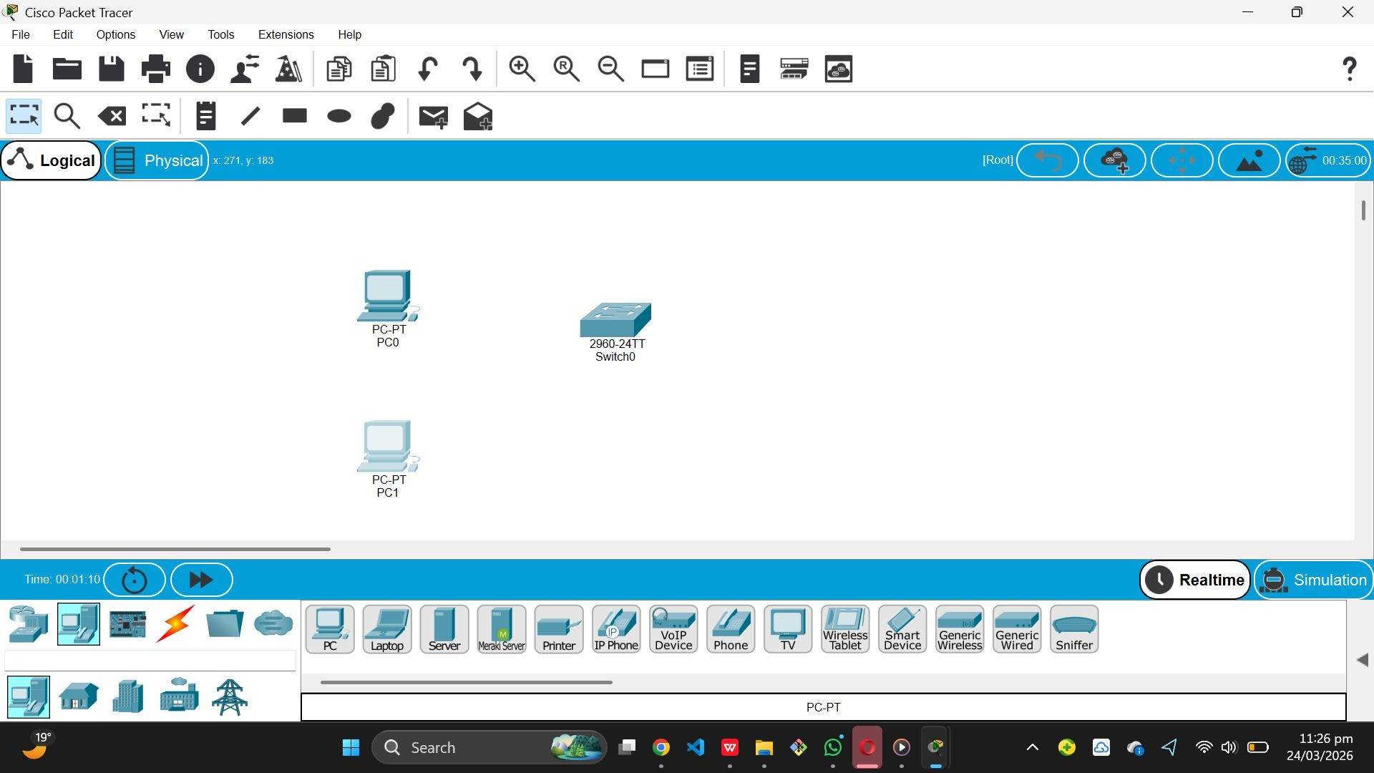

● Step 3: Connecting Devices to switch (Star Layout)
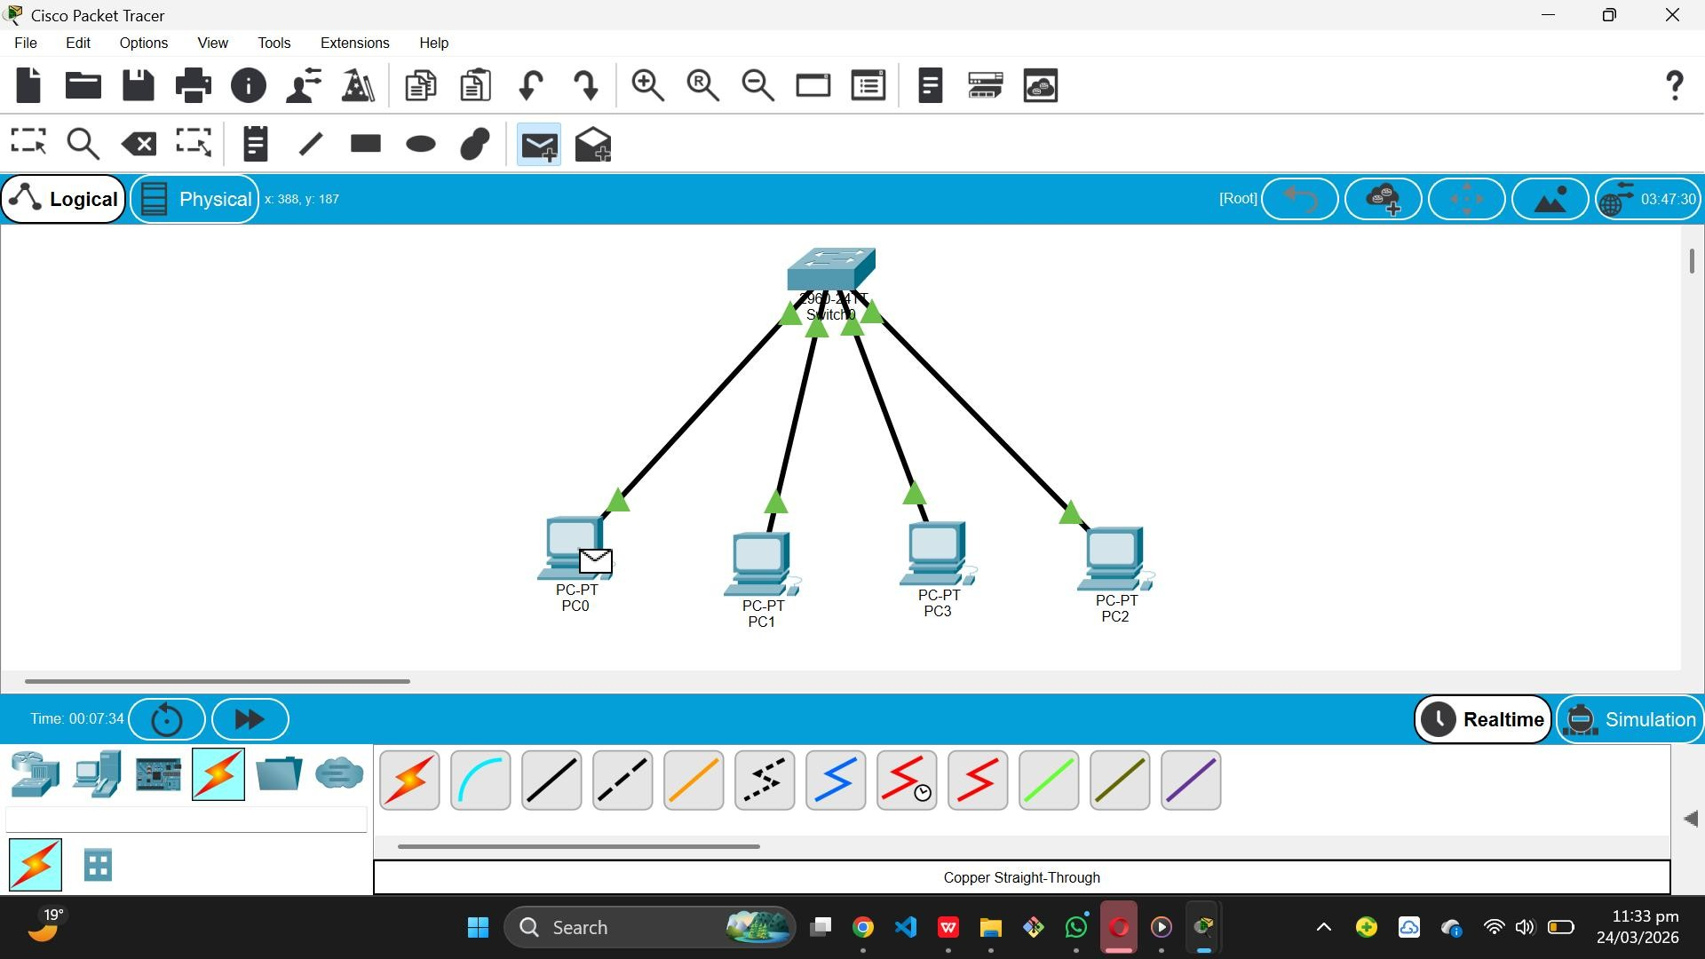

● Step 4: Configuring IP Addresses
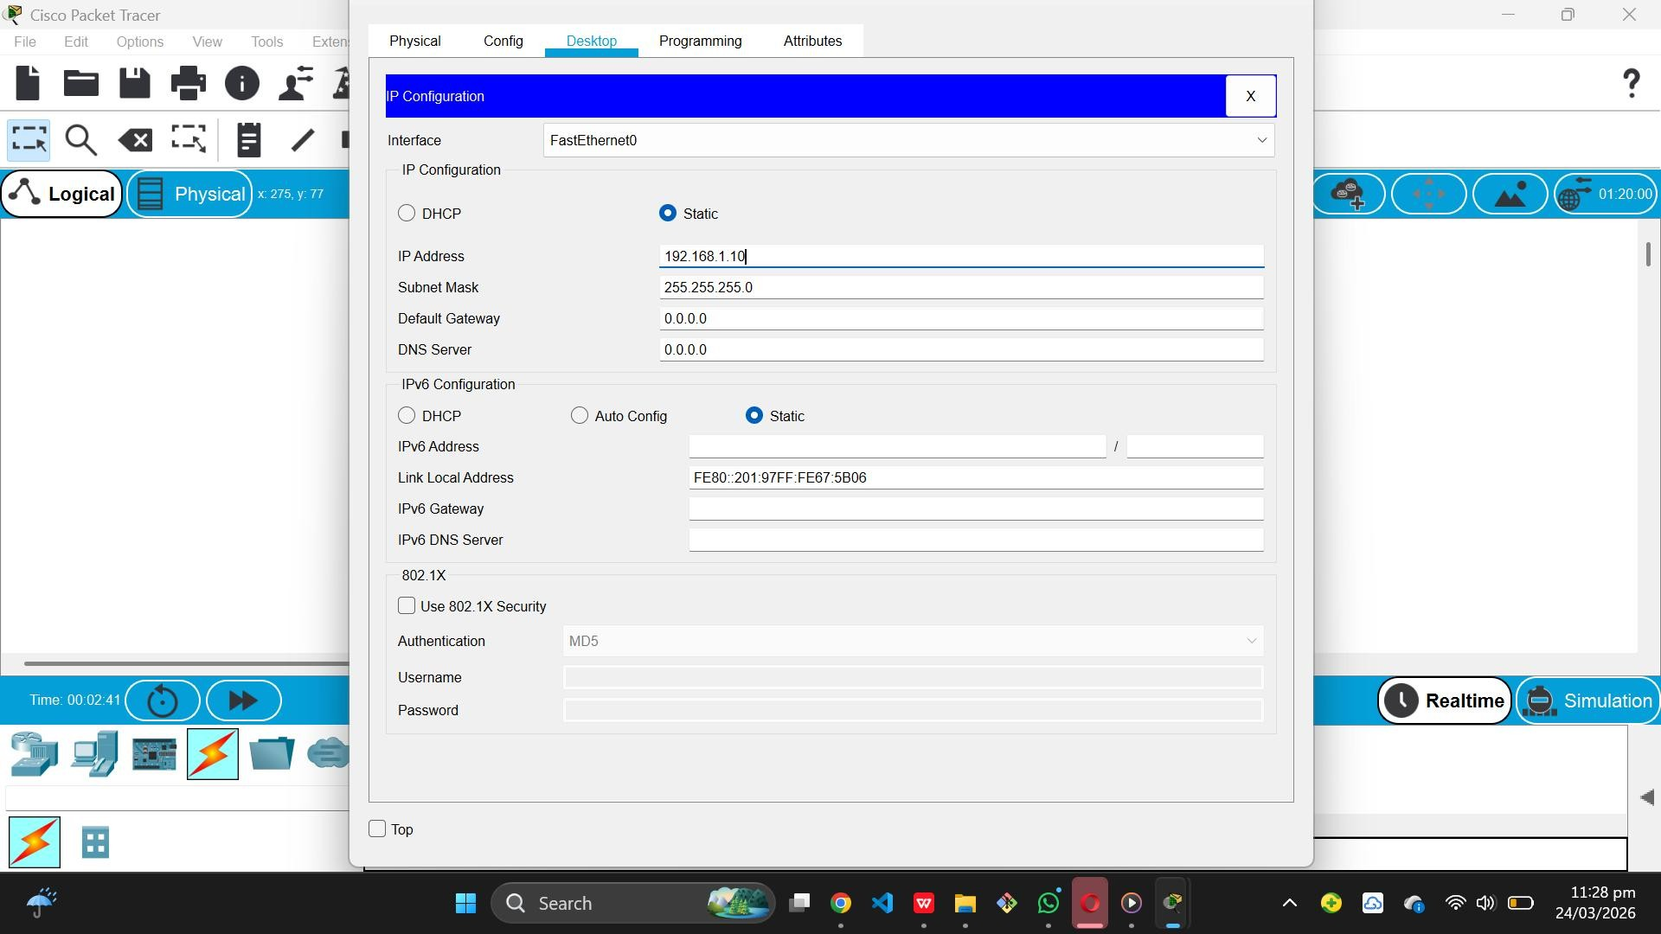

● Step 5: Ping Results and Packet Simulation
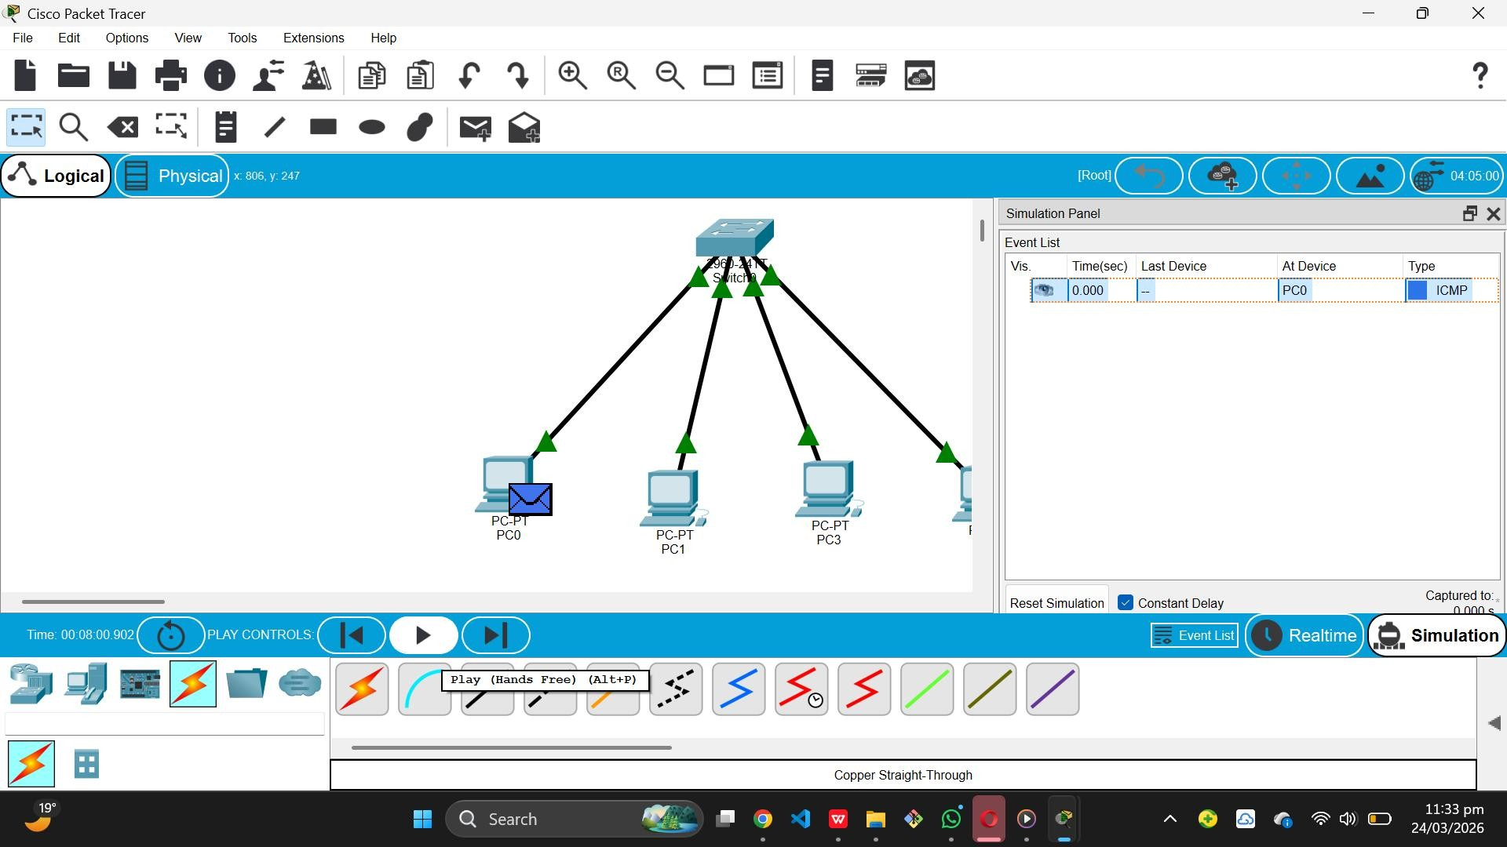

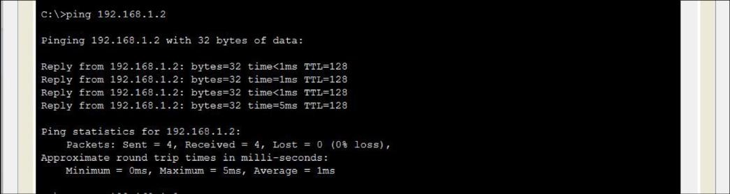

Conclusion
The star topology using a switch provides efficient communication and centralized control. It is easy to manage and troubleshoot, making it one of the most used network topologies.

